# FLiR Mounting:

A mount was fabricated to attach the FLiR sensor on to the quadcopter. The mount was made of an aluminum sheet of 0.05 inch thickness. The sheet was bent to an L-shaped and had screw holes of 0.1 inch diameter for the stand-offs.

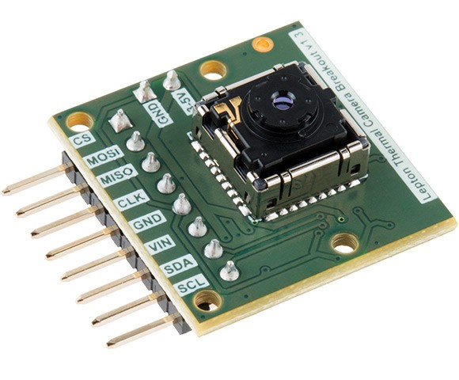

Figure 1 FLiR Sensor

The figures below shows the design specifications of the mount:

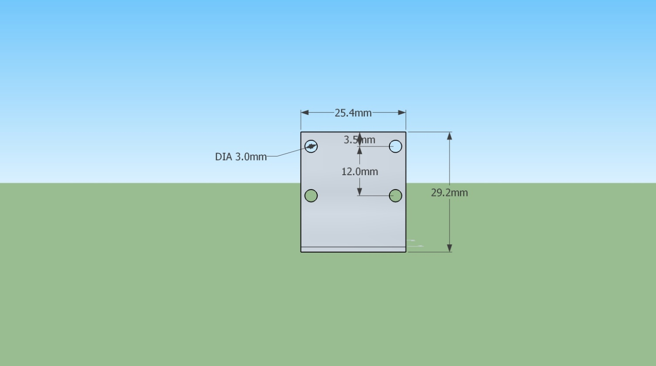

Figure 2 Front View of Aluminum Bracket

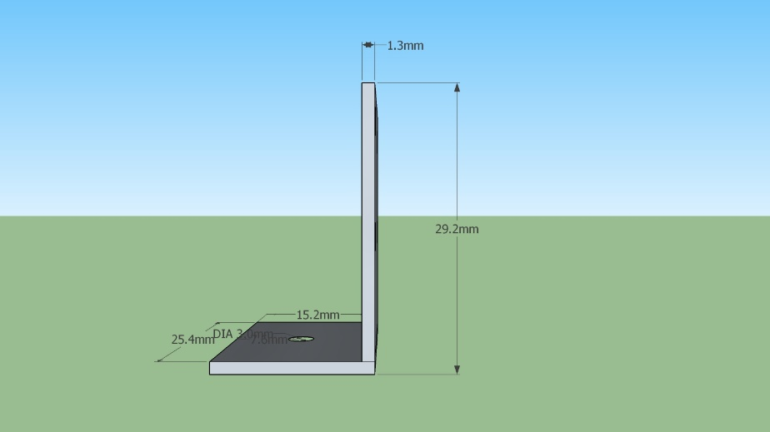

Figure 3 Side view of Aluminum Bracket

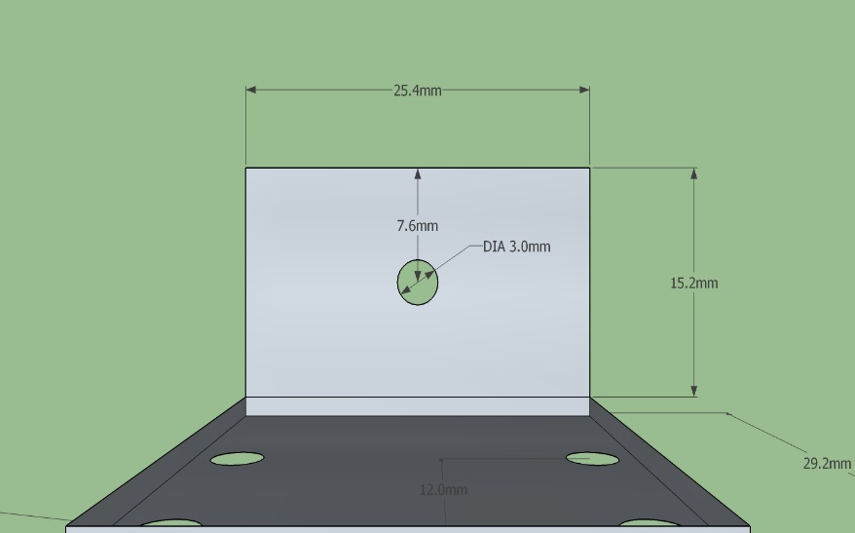

Figure 4 Top View of Aluminum Bracket

To attach sensor on to the aluminum bracket, stand-offs are needed as 2 of the connecting pins are present on the rear side of the sensor. The screw holes in the FLiR sensor are 0.1mm and there are no ready to use stand-offs available in the market. Hence, stand-offs were fabricated using a 1/8in nylon tube. Stands-offs of length 1.3in were fabricated where 0.15in was threaded on each side. The 2-56 thread size was used as it has an external diameter of 0.86 mm. The design specifications are given below:

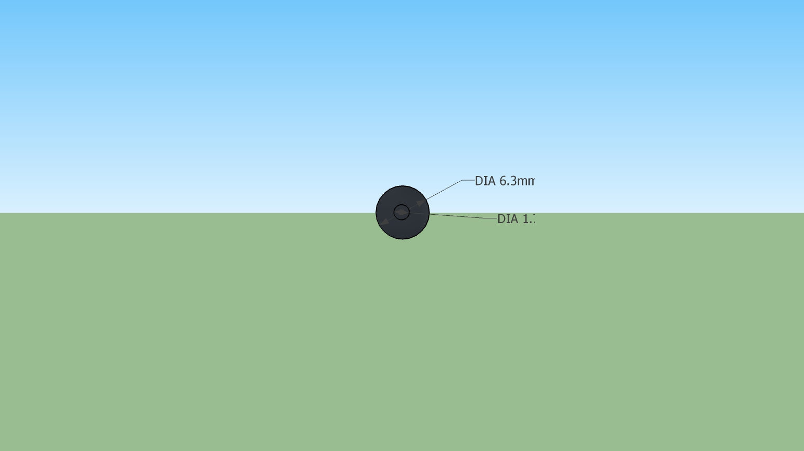

Figure 5 Front View of Nylon Stand-offs

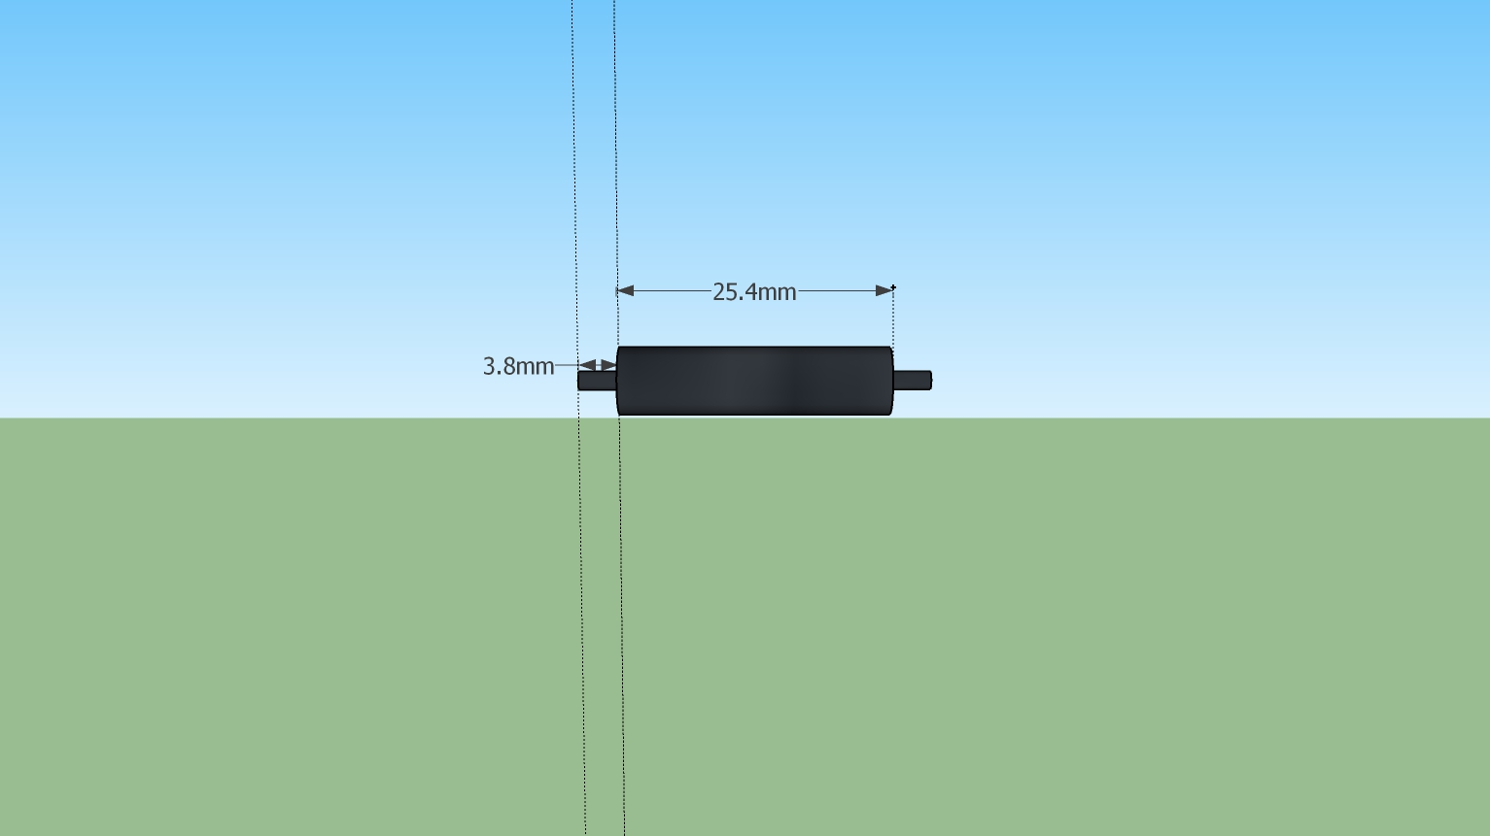

Figure 6 Side View of Nylon Stand-offs

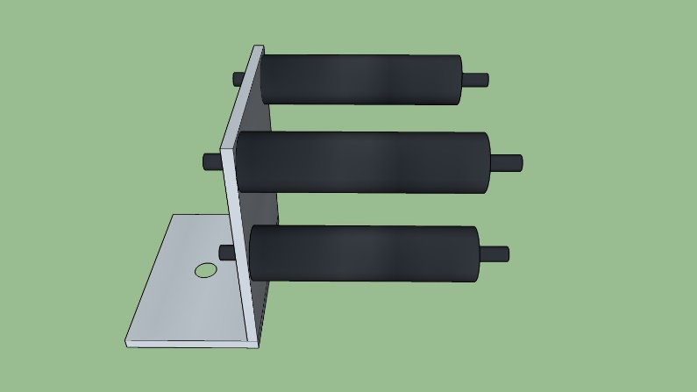

Figure 7 Image of the Final Setup

# Mounting of the Guidance Sensor:

The Guidance sensor is mounted on the Matrice 100 – Expansion Bay Kit. In addition to the Expansion Bay Kit, the Matrice 100 - Guidance Connector Kit is procure for the screws and brackets. The instructions prescribed on the DJI wiki page (http://wiki.dji.com/en/index.php/Guidance-Mounting_the_Guidance_Sensors) are followed in order to assemble the mount and attach the sensor. The Guidance core is attached to the mount with the help of double side tape (http://wiki.dji.com/en/index.php/Guidance-Mounting_the_Guidance_Core).

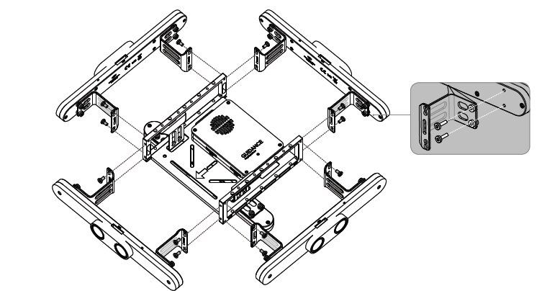

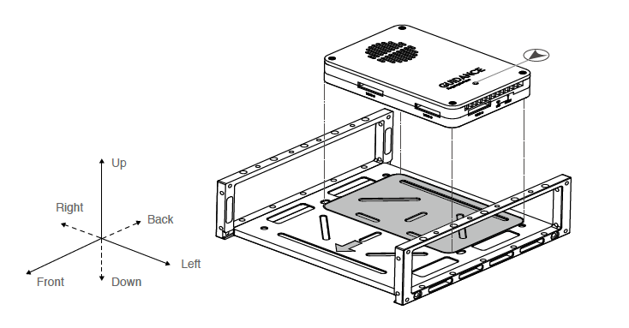

# Auto-pilots Trade Study :

A trade study was performed between different auto-pilot systems. Various parameters like weight, GPS holds, whether the flight controller software is open source etc. An excel spreadsheet was created and uploaded to the GitHub repository.

Among the 17 flight controllers that were considered, the PixHawk PX4 suits the needs of the system the best. The PX4 is open-source, cheap and the team has prior experience in using it. Hence, the PX4 was chosen.